Stock Price Prediction Model

Goutham Krishnan

Vellore Institute of Technology, Chennai

Machine Learning – BCSE209

Author Note

Include any grant/funding information and a complete correspondence address.

Abstract

This research article presents a comprehensive analysis of studies conducted using a stock price prediction model I developed. In recent years, the financial industry has witnessed a surge in the development and application of advanced machine learning algorithms for forecasting stock market trends. This study aims to provide an overview of the different approaches and techniques employed in predicting stock prices, evaluating their performance, and discussing their implications for financial decision-making.

The article reviews a wide range of studies that have utilized various prediction models, including but not limited to artificial neural networks, support vector machines, random forests, and deep learning architectures. By examining the strengths and limitations of these models, we aim to identify the factors that contribute to accurate stock price predictions and explore potential areas for improvement.

Furthermore, this article highlights the importance of feature engineering and selection, as well as data preprocessing techniques in enhancing the predictive capabilities of the models. It discusses the challenges associated with obtaining reliable and relevant data, addressing issues such as data quality, granularity, and availability. Additionally, the article examines the impact of incorporating alternative data sources, such as social media sentiment, news sentiment, and macroeconomic indicators, on the accuracy of stock price predictions.

The evaluation of prediction models is a crucial aspect of this research. We analyze the performance metrics commonly used in assessing the accuracy and robustness of the models, such as mean squared error, mean absolute error, and directional accuracy. We also discuss the significance of backtesting and out-of-sample testing in evaluating the models' performance and generalizability.

Finally, this article examines the practical implications of stock price prediction models in financial decision-making. It investigates the potential benefits and risks associated with using these models for investment strategies, portfolio management, and risk management. We discuss the challenges of implementing prediction models in real-world scenarios and explore the importance of considering market dynamics and behavioral factors in conjunction with the model's predictions.

Overall, this research article contributes to the existing body of knowledge on stock price prediction models by providing a comprehensive review of studies conducted in this field. It emphasizes the need for further research and development to improve the accuracy and reliability of these models, ultimately fostering more informed and effective financial decision-making.

Paper Title in Bold at the Top of Page 2

Begin your paper with the paper title at the top of the first page of text. Your title acts as a default Level 1 heading; therefore, it is centered and in bold. Don’t use “Introduction” as your heading as it’s assumed the introduction text will be at the beginning of your paper. The body uses a half-inch first line indent and should be double-spaced. APA style provides for up to five heading levels, shown in the paragraphs that follow.

# **Level 1 Heading**

Heading levels 1-3 get their own paragraph, as shown. Headings 4 and 5 are run-in headings used at the beginning of the paragraph. Include a period at the end of a run-in heading. Double-space all text, including headings. Use descriptive headings to help readers identify sections of your paper.

## Level 2 Heading1

To add a table of contents (TOC), apply the appropriate heading style to just the heading text at the start of a paragraph and it will show up in your TOC. To do this, select the text for your heading. Then, on the **Home** tab, in the **Styles** gallery, click the style you need.

### ***Level 3 Heading***

If needed, you can include consecutive paragraphs with their own headings, where appropriate. For APA Style formatting, type your own references. To correctly format a reference page according to APA Style guidelines, see page five.

Level 4 Heading. When using headings, don’t skip levels. If you need a heading 3, 4, or 5 with no text following it before the next heading, add a period at the end of the heading and start a new paragraph for your subheading and its text. When citing any quote or text that consists of three or more lines, APA guidelines call for block-quote format:

Create a new paragraph to begin the block-quote. Double-space each line of text, as you have done with headings, section labels, and paragraphs of paraphrased text. To correctly format a block-quote, indent each line of the text to one-half inch. Remember to always cite your source (Last Name, Year).

Last Name (Year) citations can be used when writing a paper in narrative form. Parenthetical citations are also appropriate (Last Name, Year).

Level 5 Heading. Like all sections of your paper, references start on their own page, like the page that follows this one. All in-text citations should also be included your references.

References

Last Name, A. B. (Year). Article Title. Journal Title, Pages #-#. URL. URL.

Last Name, C. D. (Year). Book TitleBook Title URL.

Last Name, D. E., Last Name, F. G. (Year). Report TitleReport Title URL.

Last Name, H. I. (Year, Month Day). Article Title/Headline. Periodical.Periodical.

Organization Name. (Year, Month Day).Webpage Title. URL.

Footnotes

1For APA reports, add footnotes manually on their own page following references. Do not use the **Insert** **Footnotes** method on the **References** tab as they will not be formatted correctly. For APA formatting requirements, it’s easier to type your own footnote references and notes. To format a footnote reference, select the number and then, on the **Home** tab, in the **Styles** gallery, click **Footnote Reference**. The body of a footnote, such as this example, uses the **Normal** text style. If you delete this sample footnote, don’t forget to delete its in-text reference at the end of the sample Heading 2 paragraph on the first page of body content in this template.

Tables

Table 1

Table Title

|  |  |  |  |  |
| --- | --- | --- | --- | --- |
| Column Head | Column Head | Column Head | Column Head | Column Head |
| Row Head | 123 | 123 | 123 | 123 |
| Row Head | 456 | 456 | 456 | 456 |
| Row Head | 789 | 789 | 789 | 789 |
| Row Head | 123 | 123 | 123 | 123 |
| Row Head | 456 | 456 | 456 | 456 |
| Row Head | 789 | 789 | 789 | 789 |

Note: Place all tables for your paper in a tables section, following references and footnotes. Start a new page for each table, include a table number and table title for each, as shown. All explanatory text appears in a table note that follows the table, like this one. Use the **Table/Figure** style, available on the **Home** tab, in the **Styles** gallery, to get the spacing between table and note. Tables in APA format can use single or 1.5 line spacing. Include a heading for every row and column, even if the content seems obvious. A default table style has been set up for this template that fits APA guidelines. To insert a table, on the **Insert** tab, click **Table**.

Figures Title

Figure 1.

Include all figures in their own section, following references, footnotes, and tables. Include a numbered caption for each figure. Use the Table/Figure style for easy spacing between figure and caption.

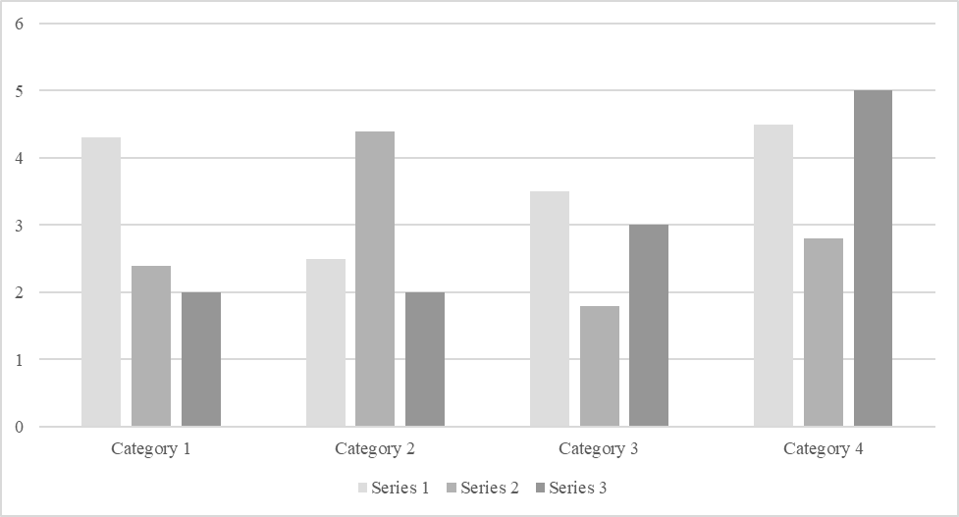

*For additional information on APA Style formatting, please consult the* [*APA Style Manual, 7th Edition*](https://apastyle.apa.org/style-grammar-guidelines)*.*